Spring term home learning
Week 3  18-22nd January  Topic – Antarctic | English | 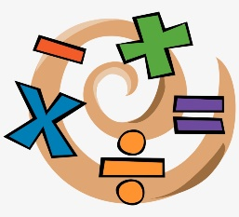  Maths | Topic/Creative | PE/Active
Task | Focus on writing your name.  Remember to use lower case letters, apart from the first letter. A grown up could write if for you to trace over.  You can add your surname if you have mastered your first name. | Numbers 1-10  Spend some time practising writing the numbers 1-10, identifying the numbers 1-10 and counting to 5.  Order the penguins from 1-10 on the worksheet. | Complete the life cycle worksheet  Are you able to design your own penguin. This could be a picture, a painting or a model. | Can you set up an obstacle course in your lounge for your family to take part in?  Ask a grown up to time people to see who can complete it the fastest.
My Montessori child at home
Remember to register for this!

You will find 'My Child at Home' invaluable when you want to plan things to do with your child, because it automatically suggests 30 activities at a time to choose from, which are tailored precisely to your particular child's evolving learning pathway. It also creates a lovely mosaic of learning photos which you can share with family and friends, so they stay connected to your child during the period of home isolation.

Register for free at https://mychildathome.com, then set-up as many as three under-6s living in your home. There's a quick demo at https://mychildathome.com/demo. A full explanation of the system can be found at Menu > Help. There’s also a little article introducing 'My Child at Home' on your My Montessori Child parents' site main page and on the At Home page.

When you set-up a child who attends the nursery, enter your My Montessori Child parents' site login details for that child on the set-up form. Observations you then make in 'My Child at Home', which are shared with family and friends, are also then automatically shared with the school, and we can easily import them into the child’s profile.

