Get Connected!
For me an important part of my practice is about Connection. Connection to myself, my body, breath and thoughts. Connection to the world around me, and Connection to others. That connection brings deeper understanding and calm when explored frequently. 😊
Today I wanted to explore that Connectivity with you all too, so we are going to be trying a few Connection breaths, a bit of mindfulness and a bit of partner work too! You can have fun doing this with your family too.

Let’s begin with Connecting with ourselves with a simple breathing exercise....
Connection with Breath...
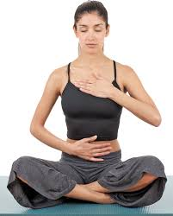
Sitting in easy pose, get yourself comfortable, with a straight but not stiff back. try sitting on a pillow to see if its more comfortable for your hips. Close your eyes and place one hand on your chest and one on your belly. Start to take big deep breaths in and out through your nose. As you breathe notice the movement of your hands as the breath fills your body and leaves again. Try to think about nothing except your breathing.
You can do this exercise with a friend or family member too, to connect not only with yourself but with each other. Sitting back to back notice the pressure of their back against your own and their gentle movements as they inhale and exhale.
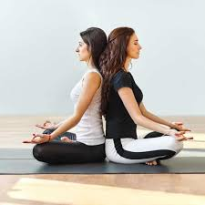

Connection with the body:
A great way to connect with your body, to see how it feels and how it moves is to do a simple sequence of movement, like the Sun Salutation for example. As you flow from one pose to another try to think about timing your breath to match some on the movements. Breathing in as you reach upwards, and breathing out as you reach downwards. This helps to calm the mind. Notice how your body feels as you move from one pose to another. Make up your own flow sequence too if you like using the poses that you know. 😊
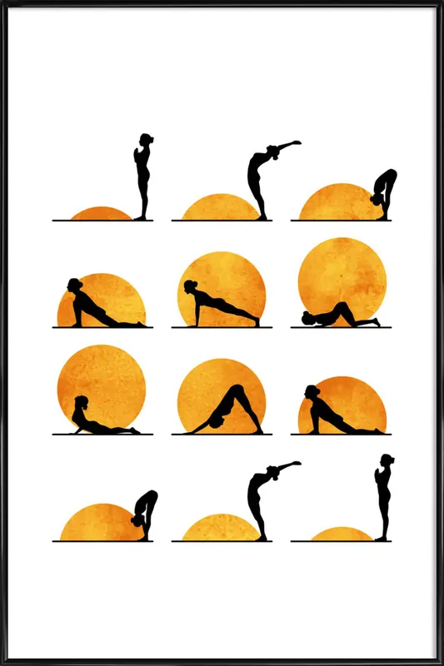 Sun salutation flow.

Doing yoga poses mindfully, really noticing how we feel we are in the pose helps us to understand our bodies better, and areas that we might hold our emotions can sometimes feel more stiff than usual!

Connect with others...

Partner poses are a REALLY fun way to connect with other people. When we do partner poses we have to work with our partner as a team, and trust each other to be sensible and to keep us safe. Here are a few fun poses you can try to copy with your family at home.
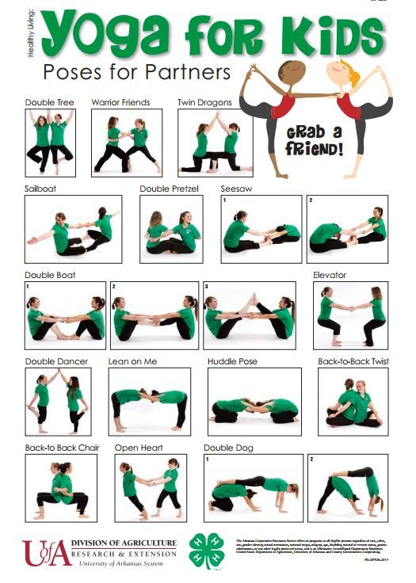

Connecting with the World Around Us...

We have a big beautiful world all around us, but how often do we REALLY take the time to notice it? Using mindfulness when we are out and exploring in the garden or out on a walk, is a great way to connect with the world around us.

Here’s a few ideas to get you thinking about how to connect with the world around us....
- Sit or lie in your garden and look up at the sky and see what shapes the clouds are making.
- Walk barefoot on the grass and notice how it feels on your feet (when its warmer!)
- Stop for a moment and close you eyes and do a senses challenge, think of 3 things you can hear, 3 things you can smell, then open your eyes and find 3 things you can see.
- Use your sense of touch on items in your home to see what they realllllly feel like when you are concentrating. Maybe get a family member to choose 5-6 items and pop them on a try or a box, and then with eyes closed see if you can work out what the items are (no peeking!!) REALLY notice everything you can about each item as you feel it, don’t be in a rush to guess, this is about noticing and connecting. So feel if it’s rough, smooth, fluffy.. Hot or cold, squishy or hard, smells nice or yucky! Describe what you are feeling out loud.
- Get an item you see all the time and see if you can notice something about it you’ve NEVER noticed before. It could be a piece of fruit, a leaf, a pet, a toy – it's your choice!

There’s so many ways to notice the world around us in a new way. See how much you can notice with your senses on your next walk!

